# **DHT11 sensor**

## -Specifications:

The sensor has Operating Voltage of 3 – 5.5 Volts, so when using Raspberry pi you can connect it to 3.3 Volts. Its operating current is 0.3mA if its measuring and 60uA if its in standby. Sensors Output is Serial data. The temperature range in which the sensor can operate is  0°C to 50°C , and the humidity range in which sensor can operate is 20% to 90%. The resolution in which it displays the values of temperature and humidity is 16-bit. Accuracy of the sensor is  ±1°C and ±1%.

Other similar sensors are: DHT22 , AM2302 and SHT71

DHT11 sensor is a commonly used temperature and humidity sensor that comes with an NTC Thermistor to measure temperature and an 8-bit microcontroller to output the values of temperature and humidity as serial data.

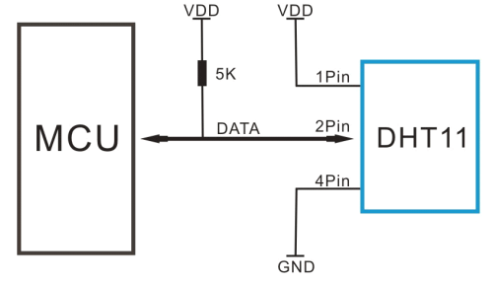

Schematics for physical connection of DHT11

As you can see the data pin is connected to an Input/Output pin of the Microcontroller and a 5K pull-up resistor is used. This data pin outputs the value of both temperature and humidity as serial data. If you are trying to interface DHT11 with Arduino or in our case the Raspberry PI then there are ready-made libraries for it which will give you a quick start.

The DHT11 sensor can either be purchased as a sensor or as a module. Either way, the performance of the sensor is same. The sensor will come as a 4-pin package out of which only three pins will be used. The module will come with three pins as shown above.

If you are trying to interface it with some other MCU then the datasheet given below will come in handy. The output given out by the data pin will be in the order of 8bit humidity integer data + 8bit the Humidity decimal data +8 bit temperature integer data + 8bit fractional temperature data +8 bit parity bit. To request the DHT11 module to send these data the I/O pin has to be momentarily made low and then held high as shown in the timing diagram below

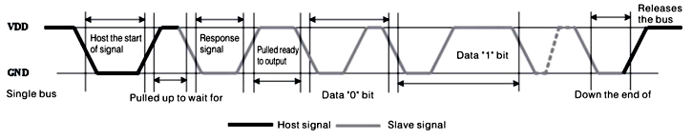

Data Timing Diagram

The DHT11 sensor can be used for many different things such as dehumidifiers, testing and inspection equipment, consumer goods, automotive, automation, data loggers, weather stations, home appliances, humidity regulator, medical and other relevant humidity measurement and control.

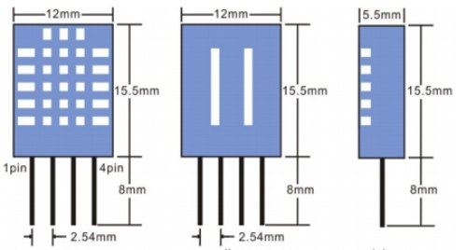

2D Image of the DHT11 Sensor

The DHT11 sensor is cheap but it has a lot of problems. Some of the problems are:

-The temperature reads only in full degrees (the decimals are always zero)

-The setup is very slow to respond (if we try to blow into the sensor it will take almost 4 seconds to get the response)

-The temperature its reading is not correct so it is not so accurate